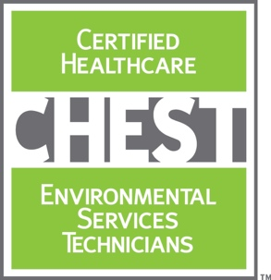
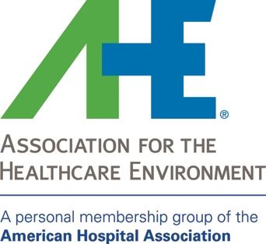

***DO NOT PRINT THIS PAGE***

***INSTRUCTIONS***

Page 2 includes an Situation-Background-Assessment-Recommendations (SBAR) worksheet to help you secure funding for attending the Certified Healthcare Environmental Services Technician (CHEST) training and certification program and rolling it out among staff at your organization.
- Print page 2 on your organization’s letterhead and provide it to your administrator for funding approval.
- Insert the appropriate metrics as highlighted on page 2.
- Feel free to customize as it fits your specific situation.

Visit www.ahe.org/CHEST to access other Justification documents for attending the CHEST training and certification program.

Name: Date:
Title: Department:
Phone, Ext.: E-mail:

SBAR

SITUATION – Briefly describe the current situation. Give a clear, succinct overview of pertinent issues.
This year we have had [X number] of HAIs at our facility, specifically [insert HAIs]. Addressing these HAIs has cost us [$XXXX]. In addition, our HCAHPs patient satisfaction scores relating to cleanliness scored at [X] and overall patient willingness to recommend the hospital scored at [X]. Finally, our employee satisfaction scores [or similar measuring tool if applicable] for environmental services technicians is at [X%], which is [X% less] compared to other frontline healthcare teams at our organization.

BACKGROUND – Briefly state the pertinent history. What got us to this point?
The environmental services team is responsible for helping our organization maintain a clean healthcare environment, which research shows proper cleaning and disinfection techniques can decrease HAI rates. However, our organization’s turnover rate for environmental services technicians is [XX% - argue if this compares higher to other frontline healthcare teams at your organization]. This creates a challenge as it costs [$XXXX – show what it costs or what you have previously spent over a year to rehire and onboard environmental services technicians, i.e., posting job ads, interviewing, orientation, training, etc. Also consider adding the amount of time needed to rehire and onboard just one environmental services technician.]

ASSESSMENT – Summarize the fact and give your best assessment. What is going on? Use your best judgment.
The environmental services team is an important component of the frontline staff. It is possible that lower staff engagement among the environmental services team is causing higher turnover rates, putting pressure on our organization to rehire and retrain new technicians on the proper techniques for cleaning a healthcare environment, which can take up to [X days, months, etc.]. Employees who are more confident in achieving their work goals are 83% more likely to be engaged than those who do not, per a 2012 study by the Society for Human Resource Management. If environmental services teams are provided with quality training that helps answer why they should clean in a prescribed and systematic way, they most likely will be more engaged, confident, and satisfied in their role, which directly correlates with lower turnover rates. Plus, an engaged environmental services team will feel more invested in their role, which ultimately should have positive effects on outcomes relating to HCAHPs scores for cleanliness and prevent HAIs.

RECOMMENDATION – What actions are you asking for? What do you want to happen next?
I recommend training and certifying our frontline environmental services team through the Certified Healthcare Environmental Services Technician (CHEST) certification program as one key aspect of the facility’s strategic plan to reduce HAIs, improve the patient care experience, and improve HCAHPS scores . The CHEST training and certification program sets national standards specifically for environmental services technicians working in healthcare and was developed by the Association for the Healthcare Environment (AHE), a personal membership group of the American Hospital Association. In addition, AHE’s CHEST program can be incorporated into our organization’s multi-pronged strategy to positively affect employee engagement, which again, directly correlates with employee satisfaction and lower staff turnover.

To implement, we will need $X,XXX in funding to send myself or another appointed staff member to become a CHEST certified trainer. Upon receiving training, myself or the appointed staff member will be able to train environmental services team members at our organization to become CHEST certified. Each certified staff member therein would need $XXX in funding to become certified. This investment includes all training materials and resources needed to train XX environmental services team members. This is an important investment because if we reduce employee turnover, or even one HAI, the program will have paid for itself (for example, treating one of the four common C. difficile infections can add up to $11,000 in added patient care costs, according to a study by the U.S. Centers for Disease Control and Prevention).

I am available for further discussion at your convenience. Thank you for your time.

